

**Lesson 13: How to download an Image into a Python Turtle Project**

Python Turtle Graphics allows you to use images downloaded online or from any other resource and generate animations. With Turtle, you can only use gif. files. Let’s start with a code example#1 shown below: this example demonstrates how to insert aquarium (background image) and fish image (turtle image) in it.

**Fish in Aquarium (one direction movement)**

Code:

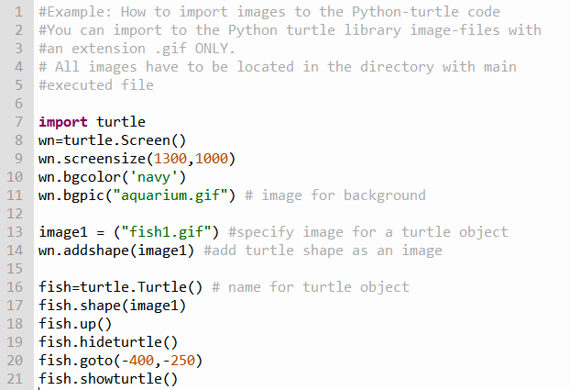

Result:

Keep in mind that Python Turtle accepts files written with extension.gif only. If you have chosen an image that has a .png. jpg, or jepg, extension, you have to convert it to a file with the extension .gif. Аll image files(extension gif) should be imported into the same directory where the main file is located.( py extension) is located.

**Key lines in the code:**

1. Line #11 specifies background image (The name of gif file is aquarium.gif.
2. Line #13 specifies a variable image1 with fish image ( file name is fish.gif)
3. Line #14 adds fish file to the screen.
4. Line #17 allows us to use our fish image as a turtle sprite image. After we determined turtle object as a fish (instead of our original options, like turtle, circle, square, triangle…) we can apply our main turtle commands to the fish image.

Code result is shown below

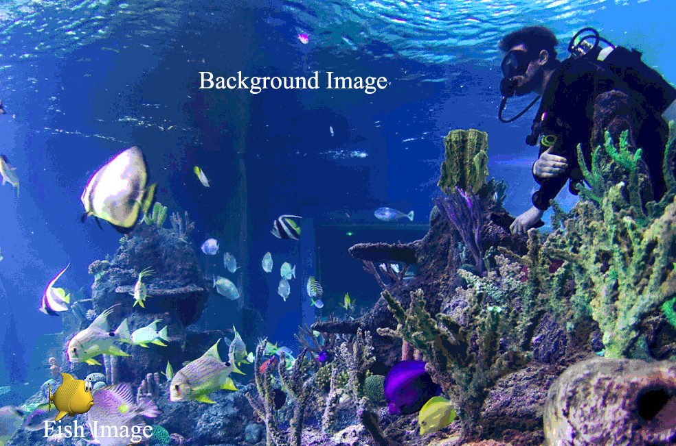

1. **Example #2** (Fish moves in aquarium in horizontal direction)

Code:

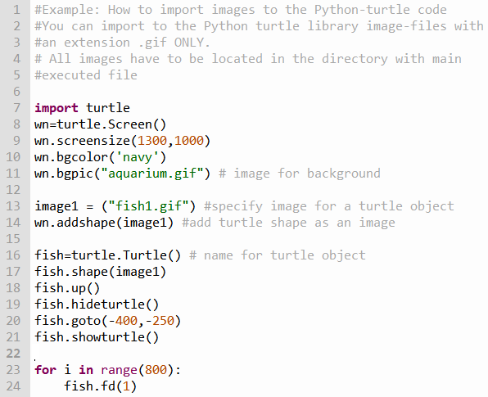

This code demonstrates motion of a fish along the horizontal line 800 pixels from the left side to the right side)

**Fish in Aquarium (two directions movement)**

(Fish moves in horizontal direction from the left side to the right, then turns left and moves from bottom of the aquarium to the top)

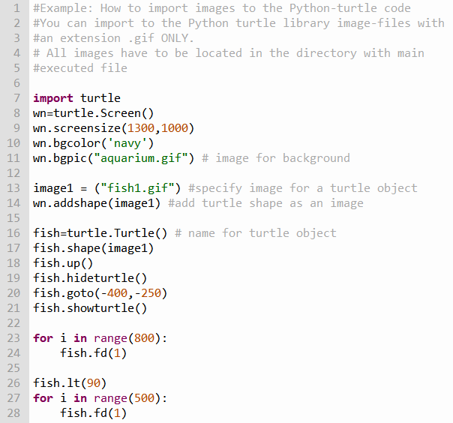

Result:

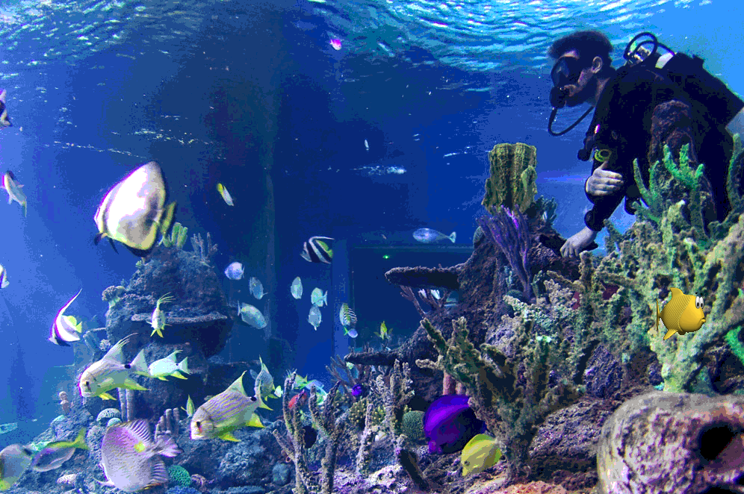

As we can see from the resulting fish moves from the aquarium bottom to the top, however, fish does not turn itself

Therefore, if we want fish to turn on 90 degrees we have to add a second image and switch from first to the second image depends on the motion direction. Code with inserted images looks like:

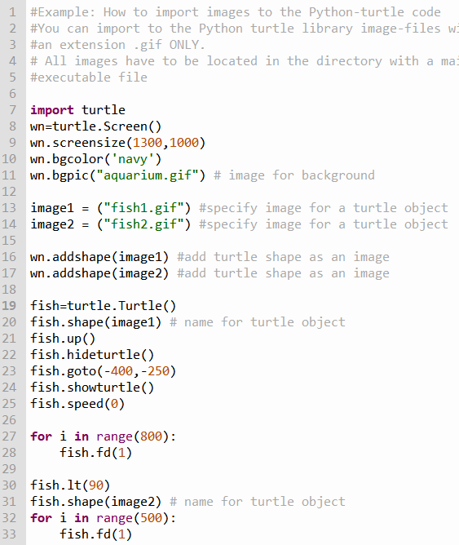

As you can see we added to the screen image #2 with second position of the fish (Line #17), use fish1.gif for horizontal movement (Line #20) and file fish2.gif for vertical movement (Line #31)

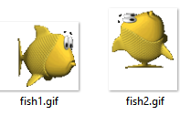

Code result (two pictures: first one corresponds horizontal movement, and second one – to vertical movement) is shown below

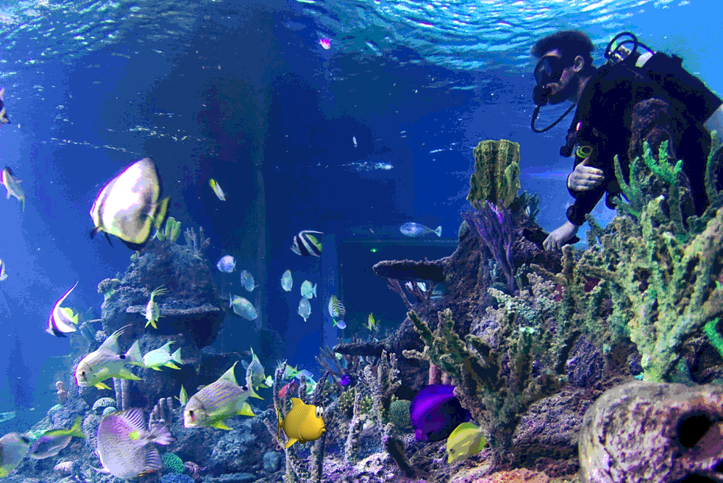

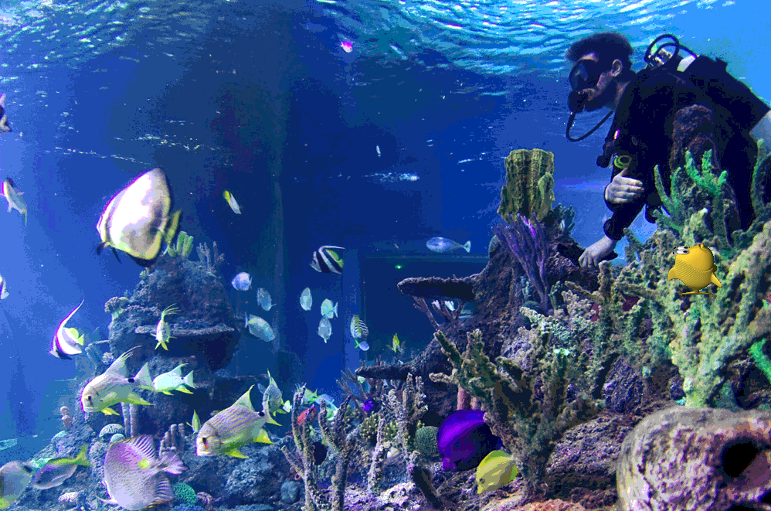

Now we can create the code that imitates the movement of the fish around the aquarium.

Code:

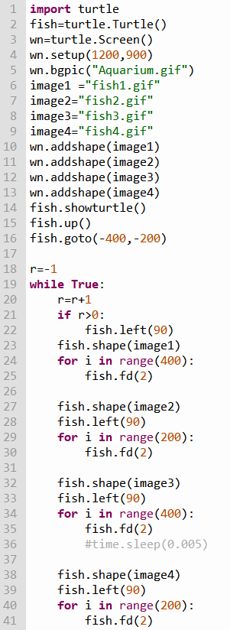

It is seen that code uses four images of fish with different orientation

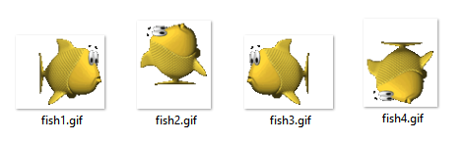

and switches one image to another depends on the motion direction. Loop while True provides continuous movement of a fish around the aquarium.

It is very important that that we need images with transparent parts around the images because when one image passes over or near another as it moves across the screen, we don’t want the background of one image to wipe out one part of another. For example, in these images, the checkerboard pattern in the background represents the transparent area:

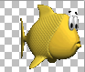 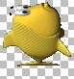 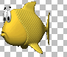 

Code shown below demonstrates how to animate fish moving across the aquarium. Each of the four fish files is represented by two different files as shown below: 2 files for horizontal movements from left to right, 2 files for horizontal movements from right to left, 2 files for vertical movement from bottom to top and 2 files for vertical movements from top to bottom.

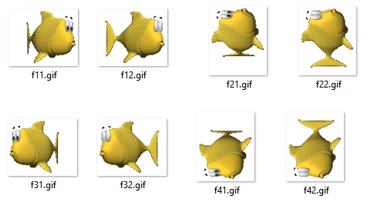

Code:

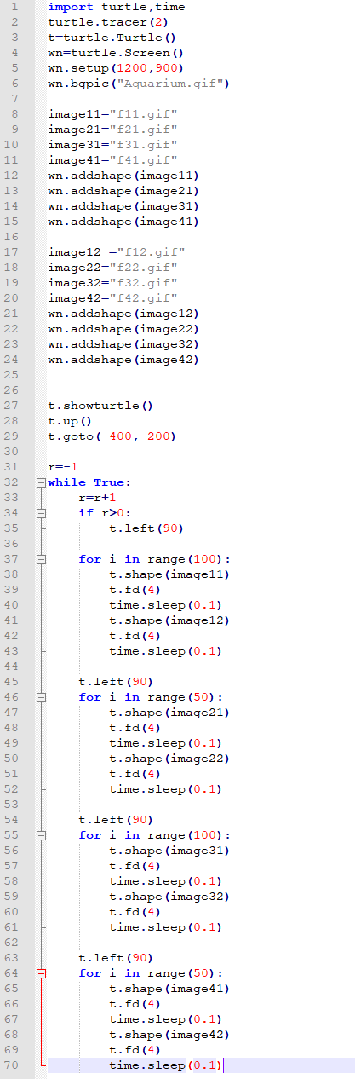

The video below shows the final result (click on the link to watch video)

<https://www.youtube.com/watch?v=4wKyoa5SHqc&feature=youtu.be>

**Astronaut with Shuttle in free space**

In this example, we create the following Python project: astronaut outside of a shuttle is moving in free space.

Static code result:

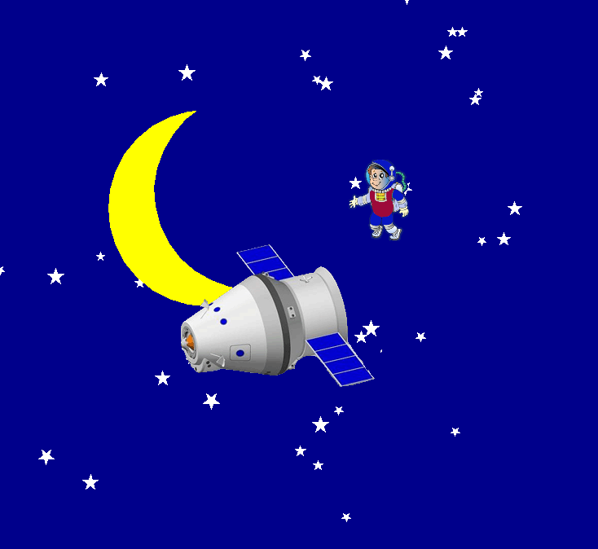

Video below shows the final result (click on the link to watch video)

<https://www.youtube.com/watch?v=HD1T0ivKHGE>

The Final code looks like:

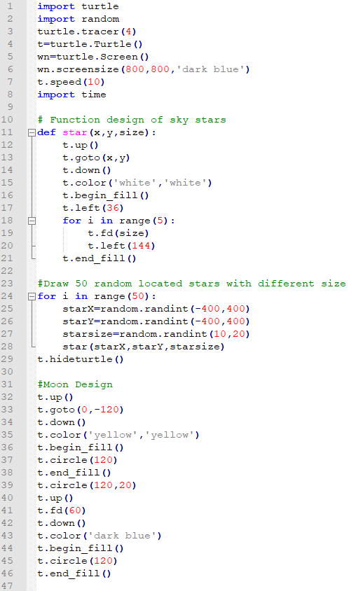

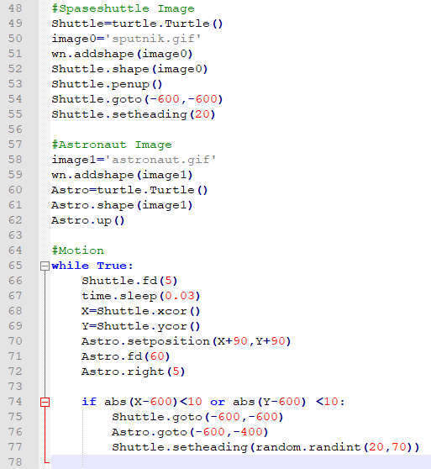

This code includes **two** inserted images: line #50 for Sputnik and line #58 for the astronaut. We have found these images online, converted each of them to gif files and inserted them into the code. You can find all these images with the gif extension in Lesson #13, Example #3. Build this code with images and see how it works. Again, keep in mind that files: **sputnik.gif**, **astronaut.gif** and the file with the main code have to be located in the same directory. If you are familiar with the technique for converting gif images, you can try different images with the same code. Pay attention to the lines #74-77. These lines allow us to start the shuttle and astronaut motion from the left side when images reach the right border of the screen.

**Running Boy**

Code:

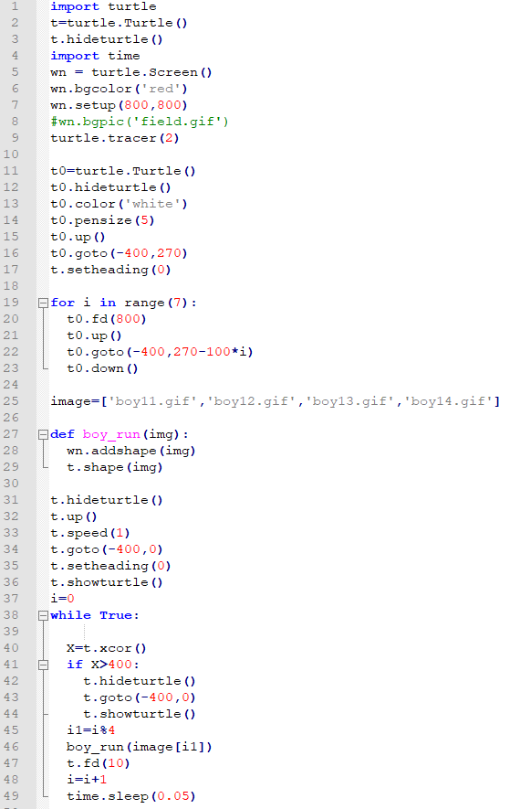

Take a look at this code. To generate the animation effect we have chosen four different image-positions that create the illusion that a boy is running.

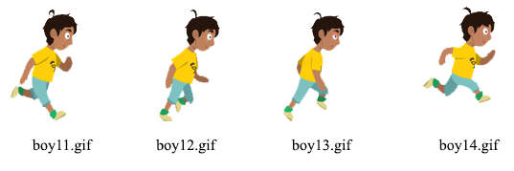

Each position of the boy is determined by its own image file (line #25) and specified with a list of images. You will find these four .gif images at python.kidsgo.ca Lesson #13 and you can download the corresponding files to your computer. You can name the images however you want. Although, you have to put corresponding image file names into line #25. For example, let’s name the image of the first boy **b1.gif**(instead boy11.gif), the second boy **b2.gif**(instead boy12.gif), the third boy image **b3.gif**(instead boy13.gif), and the fourth boy image **b4.gif**(instead boy14.gif). In this case, line #10 should be **image=['b1.gif ', 'b2.gif ', 'b3.gif ', 'b4.gif ']**

These four images are one animation cycle. This loop cycle is constantly repeated creating the illusion that the boy is running. Pay attention to lines #45 and #46. Line #45 creates the variable **i1** that takes on values 0,1,2,3 (only four values) which means the positions can only be image [0], image [1], image [2], and image [3].

Lines #41-44 are the commands that allow the boy to start running from the left side to the right side.

Static code result looks like:

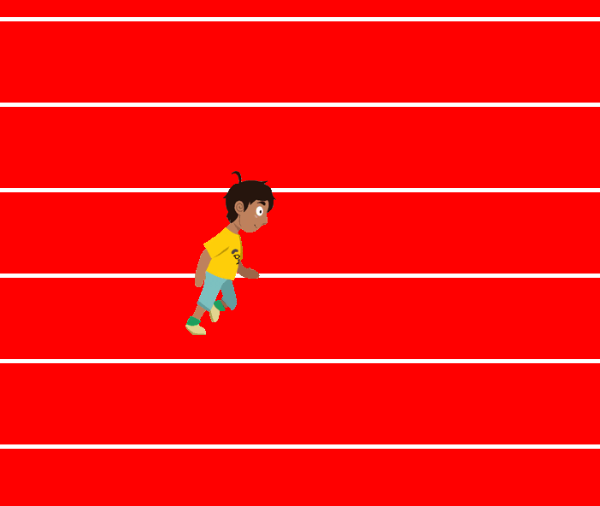

The video below shows the final result (click on the link to watch video)

<https://youtu.be/2bWR8q8aumg>